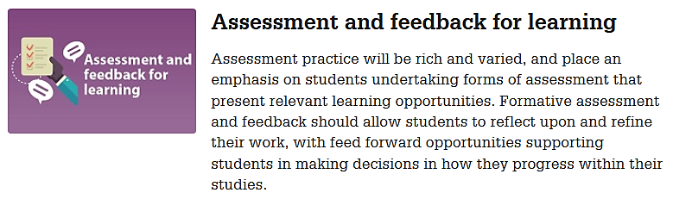
When you design your assessments, you should start with your learning objectives and then work your way down to summative and finally also formative assessments.
Start by listing the learning objectives for your module / unit / course. These learning objectives can be found in handbooks, semester / module / unit / course maps and other module / unit / course documentation.
How I (could) implement this value in my teaching
Learning Objective
Continue to list the summative assessments (assessments of learning at the end of a topic or semester) you will use to evaluate whether a student has accomplished the learning objectives for your module / unit / course.
You should also think about which format these assessments have at the moment (i.e. exam, presentation, research paper, practical task, etc.) and which tools (inside or outside Brightspace) you are using at the moment to conduct the summative assessment(s).
Next think about how the format of the assessment might change and which tools (inside or outside Brightspace) you think you will use for the summative assessment in the next semester.
Summative assessment
Current assessment format
(Brightspace) tool(s) used for summative assessment at the moment
Revised assessment format for 2020/21 online delivery
Brightspace tool(s) used for summative assessment next semester

Now, think about which formative assessments (assessment for learning) you are incorporating in your teaching at the moment to help students prepare for the summative assessment.
You should also think about which format these assessments have at the moment and which tools (inside or outside Brightspace) you are using at the moment to conduct the summative assessment(s).
Next think about how the format of the formative assessment might change and which tools (inside or outside Brightspace) you think you will use for the formative assessment in the next semester. You should also think about whether you will need to add any further opportunities for formative assessment, particularly to give students a chance to try out any new tools you might use for summative assessments.
Current formative assessment
Current assessment format
(Brightspace) tool(s) used for formative assessment at the moment
Revised assessment format for 2020/21 online delivery
Brightspace tool(s) used for formative assessment next semester
Additional formative assessments

